# Site Flow and Sketches

## Step 1: Competitive Analysis

|  |  |
| --- | --- |
| Competitor Site 1: <Alaska Airlines1> URL: < https://www.alaskaair.com> AnalysisWhat is good about this site?  1. <Everything you need can be found in one main box on the main page> 2. <Font is perfect sized - you don’t have to scroll to find what you need> 3. <The background of Seattle is calming, making the user less stressed and it is pretty making them excited to travel>  What is bad about this site?  1. <Deals and Promotions are not as obvious> 2. <Because the background image fits the screen perfectly, you might not know to scroll down for other information > 3. <The private theater section is too large > | Competitor Site 2s: <Southwest Airlines> URL: <https://www.southwest.com> AnalysisWhat is good about this site?  1. <Flights can be booked on main page > 2. <Special offers are on main page – easy to find, easy to read> 3. <Most important details for planning trips are shown on main page (flight, hotel, car, vacations, check in, flight status, change flight)>  What is bad about this site?  1. <Font is too big can be slightly difficult to read> 2. <Because font is so big, they cannot fit as much onto one viewing screen without having to scroll> 3. <Points section is too big, wastes space> |

### Competitor 1 Pages

#### Page (or Screen) where you ask “What should I do tonight?”

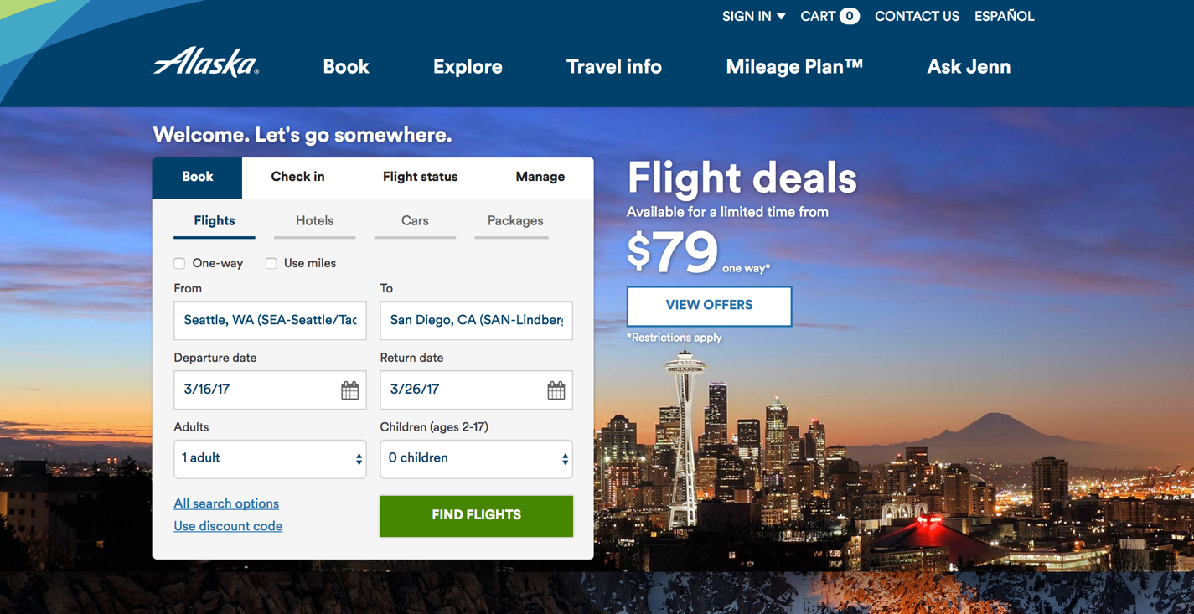

#### Pages (or Screens) look for the answer

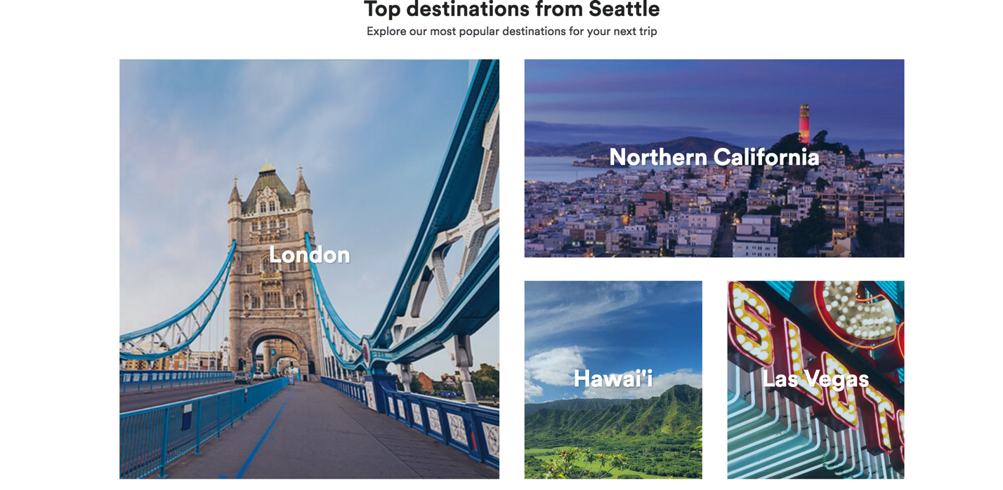

#### Page where you get an answer ../Desktop/Screen%20Shot%202017-01-25%20at%202.37.50%20PM.pn

### Competitor 2 Pages

#### Page (or Screen) where you ask “What should I do tonight?”

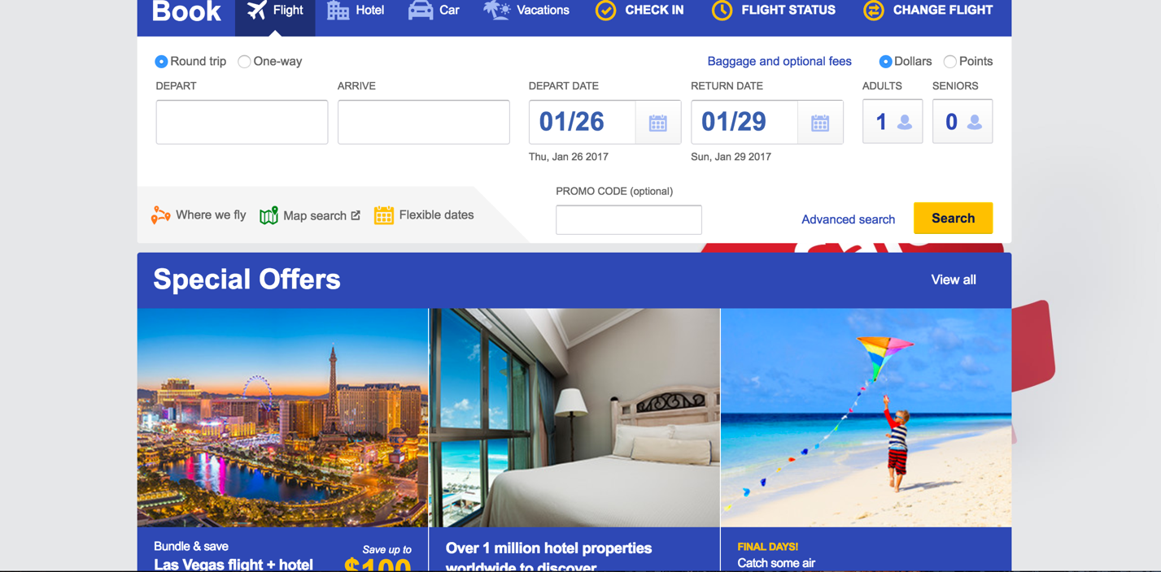

#### Pages (or Screens) look for the answer

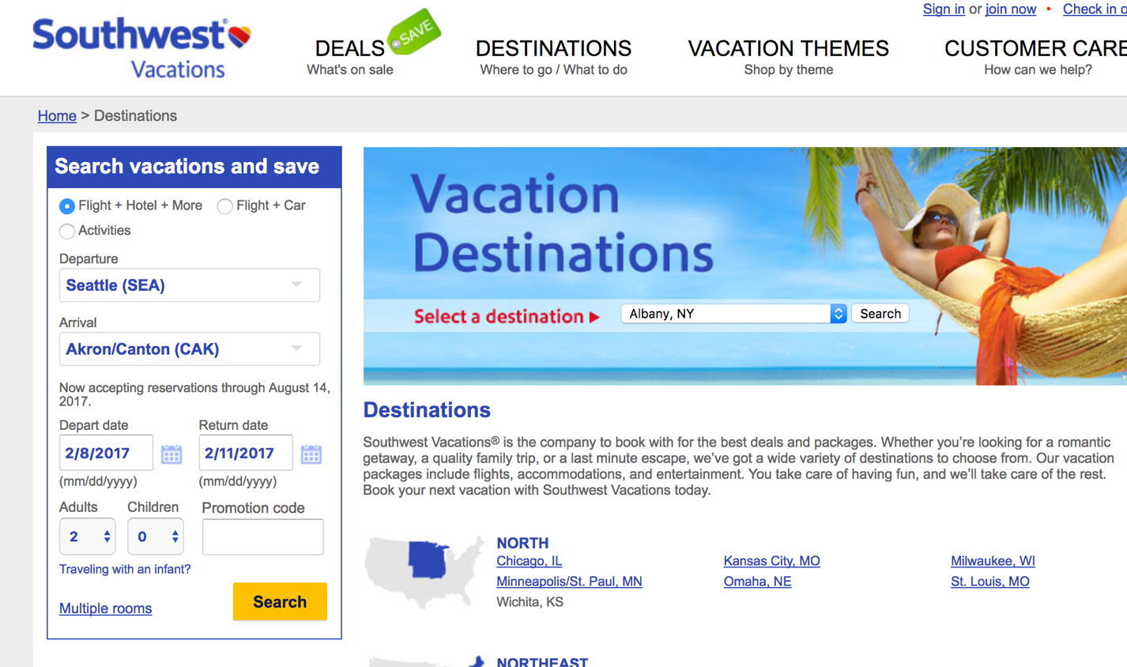

#### Page where you get an answer

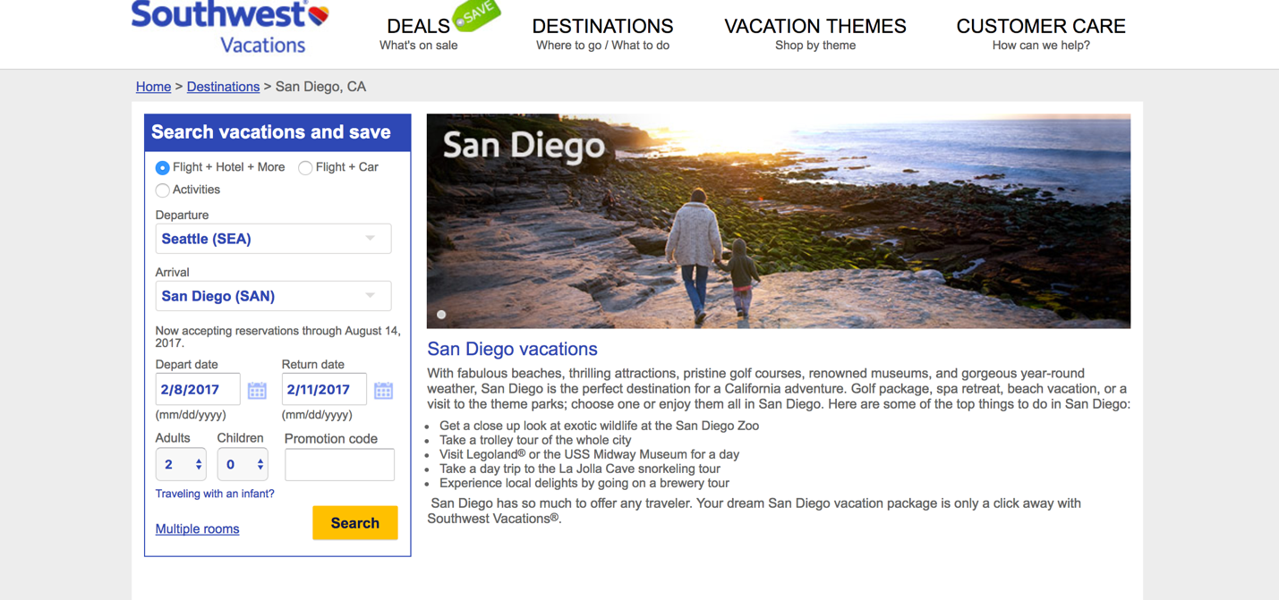

## Step 2: Sketch One Competitor Flow

### Favorite Competitor: Page Flow Sketch

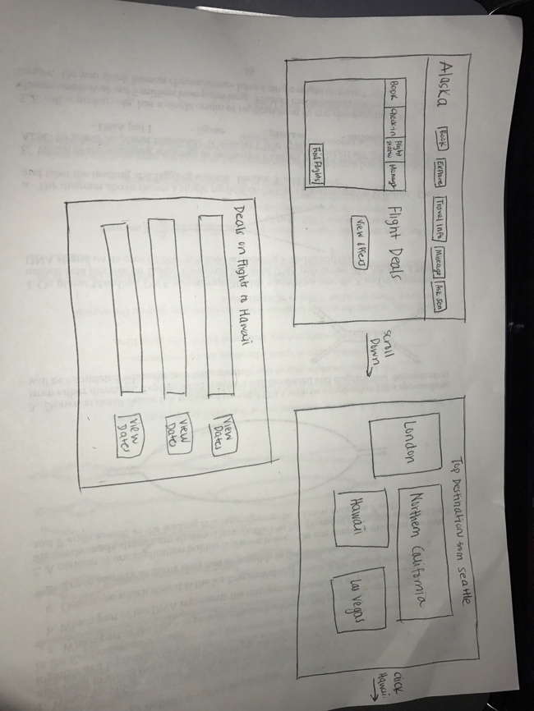

## Step 3: Sketch YOUR Flow

### My Site Name

<Springer’s Party Planes>

#### Sketch of My Page Flow

Pages sketched as boxes for the flow between pages (or screens) where you ask “What should I do tonight?” Arrows drawn between the boxes show how the pages are connected by clicks. Inside the page boxes details include:

